NAME: EKENG, AKANINYENE IME
COURSE: SECURITY OPERATIONS CENTER (SOC) FUNDAMENTALS
COHORT: NOVARA 28 NOVERMBER 2025
DATE:18/02/2026
ASSIGNMENT FOR WEEK8 (INCIDENCE RESPONSE) II
TASKS TO COMPLETE:

Subject: Unusual Login Activity Detected

From: Microsoft Security Team info@libreriacies.es

To: sonyundefinedralph@gmail.com

Dear User,

We detected unusual login activity on your email account from a new device located outside your usual region.

To prevent temporary suspension of your account, please verify your identity

immediately by

clicking the link below:

https[:]//tinyurl[.]com/ypu5kfts

If you do not verify your account within 24 hours, access to your mail box may be restricted

For security reasons.

Please find attached a copy of the security report related to this activity for your reference.

Thank you for helping us keep your account secure.

Microsoft Security Team

IT Support Desk

Using appropriate SOC investigation techniques and tools, answer the following:

1.Identify all Indicators of Compromise (IOCs) present in the email.
2.Investigate the email addresses and state your findings.
3.Analyze the sender’s domain and comment on its reputation and configuration.
4.Analyze the embedded URL safely (do not click the link) and determine whether it is malicious or suspicious.
5.Based on your findings, determine whether this email is a phishing incident and justify your answer

ANSWERS
- The indicators of compromises (IOCs) in this email includes:
- Please verify your identity immediately-urgency in the email
- Dear User: it is not personalized therefore it looks suspicious
- Link: the link is not written in an normal format therefore it looks suspicious
- If you don't verify your account within 24hours access to your mailbox may be restricted: This line sounds like a Threat.
- After my investigation on the senders email, it appears that the sender email has 0 data breach on (haveibeenpwned website)
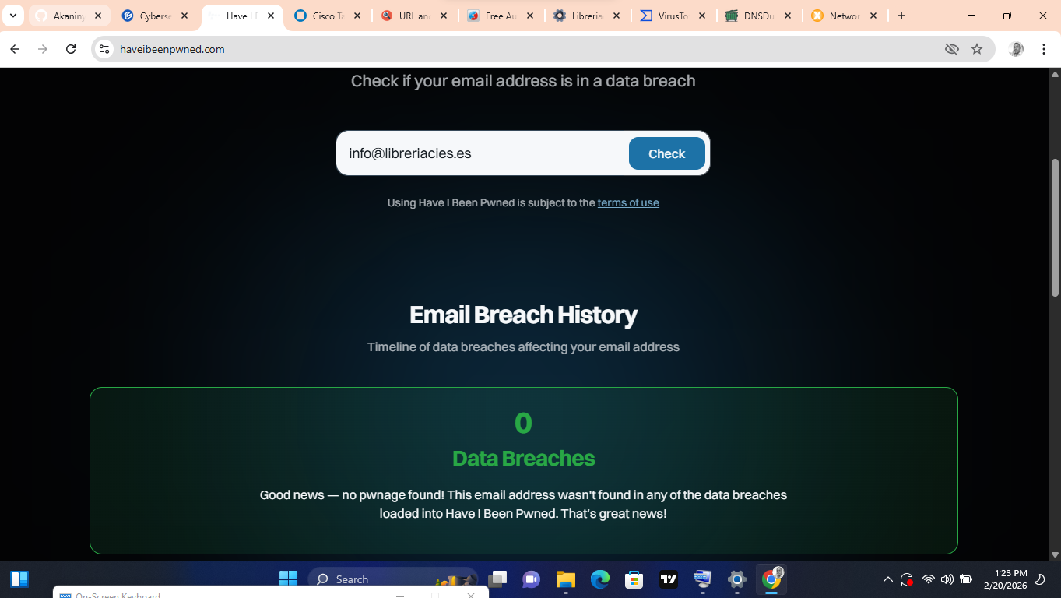

- On talosintelligence.com, the sender domain is libreriacies.es and it's reputation details appears Neutral.
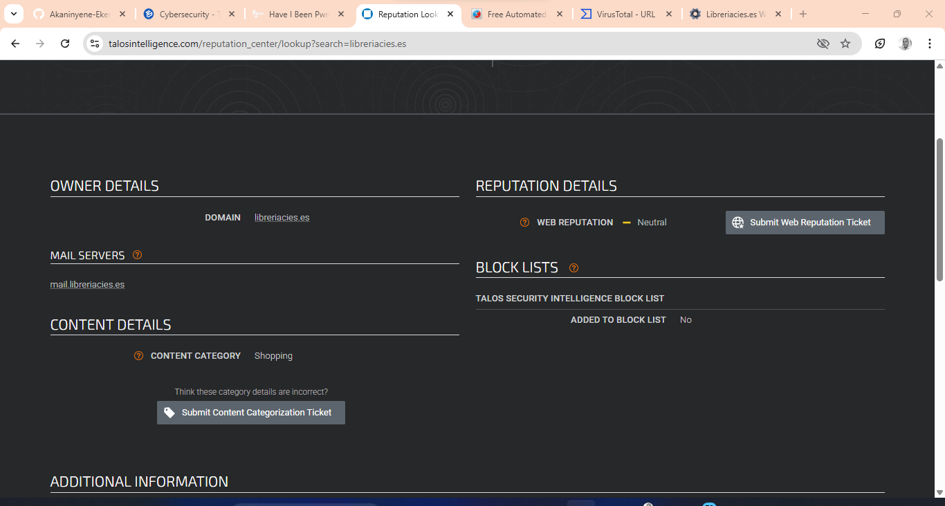

On whois.domaintools.com it looks malicious because the registry for this domain name does not publish ownership record.
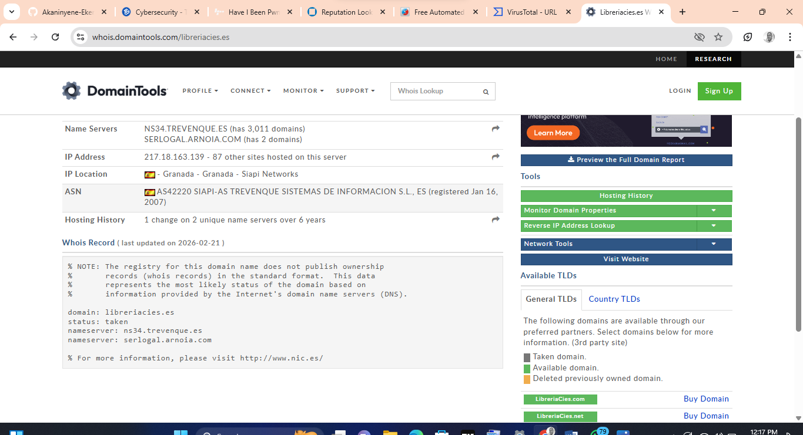
4 On virus total.com it appears that 6 security vendors flagged this URL as malicious.
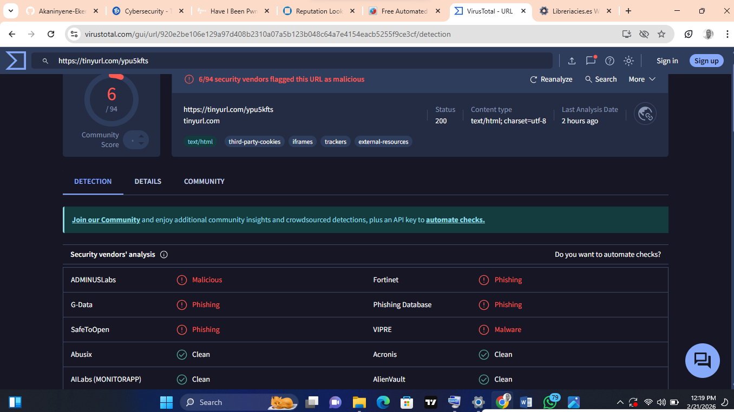
The server name is Cloudflare
It's serving Ip: 104.18.111.161
Date created: 20, Feb 2026
No much details on virus total.com
While
On hybrid analysis.com,
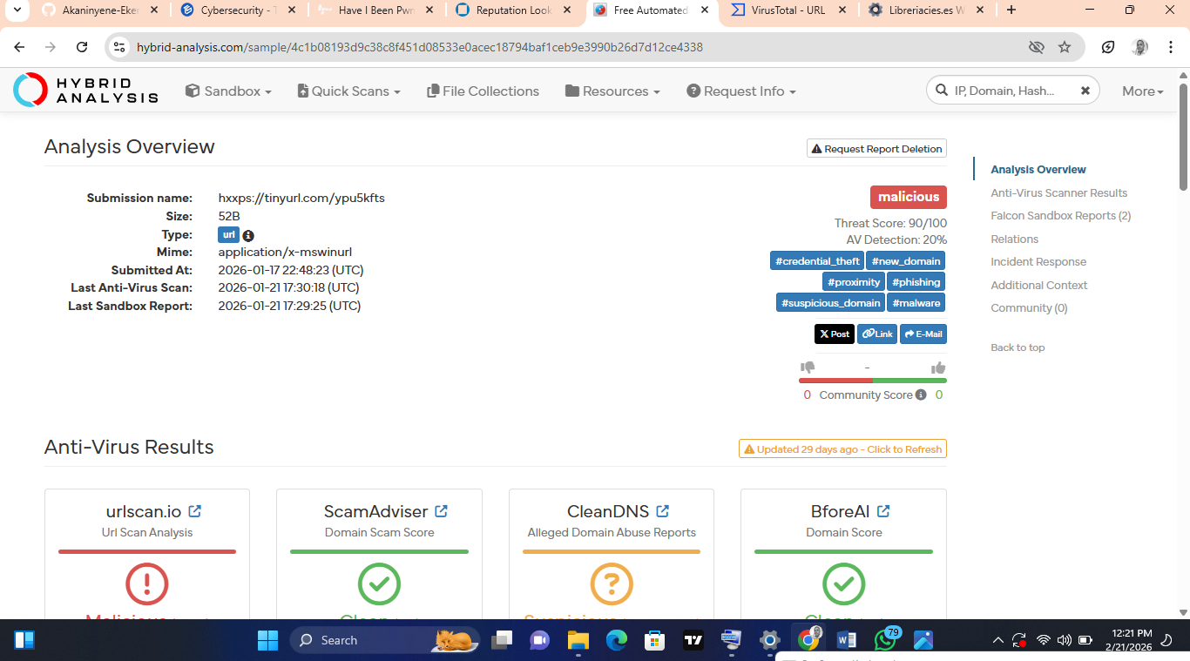
threat score appears 90/100
Av Detection:20%
URL scan analysis: 100%
Domain scam score: (0%)
Alleged domain Abuse Reports: Suspicious (2317)
Criminal score : clean (50%)

5. After my overall findings, this email appears to be a phishing email because from its content so many red flags were spotted, the link was flagged by 6 vendors on virustotal.com and on hybridanalysis it has 90/100 threat score which appears to be malicious finally, the sender domain name does not have a published ownership record which appears suspicious.

